Product Specification

Model Name | S123HWU08EP
Description | 12.3" WUXGA  1920(RGB)x720 Dots
Date | 2022/03/23
Version | 1.0

Customer Approval
Date
Approved  by/Date | Check  by/Date | Prepared  by/Date
ZHP 2022/03/23 | HL 2022/03/23 | ZWF 2022/03/23

Table of Contents

1. Record of Revision 3
2. General Specifications 4
3. Input/Output Terminals 5
4. Absolute Maximum Rating 6
5. Electrical Characteristics 6
6. Interface Timing 8
7. Optical Characteristics 11
8. Environmental / Reliability Tests 14
9. Mechanical Drawing 15
10. Packing 16
11.Precautions for Use of LCD modules 17

Record of Revision
Rev | Issued Date | Description | Editor
1.0 | 2022/03/23 | First Release | ZWF

General Specifications
Feature |  | Spec
Characteristics | Size | 12.3 inch
Characteristics | Resolution | 1920(horizontal)*720(Vertical)
Characteristics | Interface | 2 port LVDS
Characteristics | Connect type | Connector
Characteristics | Display Colors | 16.7M
Characteristics | Technology type | a-Si
Characteristics | Pixel pitch (mm) | 0.1521*0.1521
Characteristics | Pixel Configuration | R.G.B.-Stripe
Characteristics | Display Mode | Normally Black
Characteristics | LCD Driver IC | TBD
Characteristics | Viewing Direction | ALL
Mechanical | LCM (W x H x D) (mm) | 302.10*125.50*6.35
Mechanical | Active Area(mm) | 292.03 *109.51
Mechanical | Weight (g) | TBD
Mechanical | LED Numbers | 44 LEDs

Note 1: Requirements on Environmental Protection: RoHs
Note 2: LCM weight tolerance: +/- 5%

Input/Output Terminals
1 | GND | Power ground
2 | NC/BIST | No Connector(BIST Pin)
3-4 | VCC | Power input
5-6 | GND | Power ground
7-8 | NC | No Connector
9 | GND | Power ground
10 | RXOIN0- | -LVDS differential data input (Odd data)
11 | RXOIN0+ | +LVDS differential data input (Odd data)
12 | RXOIN1- | -LVDS differential data input (Odd data)
13 | RXOIN1+ | +LVDS differential data input (Odd data)
14 | RXOIN2- | -LVDS differential data input (Odd data)
15 | RXOIN2+ | +LVDS differential data input (Odd data)
16 | RXOCLKIN- | -LVDS differential clock input (Odd clock)
17 | RXOCLKIN+ | +LVDS differential clock input (Odd clock)
18 | RXOIN3- | -LVDS differential data input (Odd data)
19 | RXOIN3+ | -LVDS differential data input (Odd data)
20 | RXEIN0- | -LVDS differential data input (Even data)
21 | RXEIN0+ | +LVDS differential data input (Even data)
22 | RXEIN1- | -LVDS differential data input (Even data)
23 | RXEIN1+ | +LVDS differential data input (Even data)
24 | RXEIN2- | -LVDS differential data input (Even data)
25 | RXEIN2+ | +LVDS differential data input(Even data)
26 | RXECLKIN- | -LVDS differential clock input (Even clock)
27 | RXECLKIN+ | +LVDS differential clock input (Even clock)
28 | RXEIN3- | -LVDS differential data input(Even data)
29 | RXEIN3+ | +LVDS differential data input (Even data)
30 | GND | Power ground
31 | FAULT | FAULT signal output (normal=H,abnormal=L) Note1
32 | RESET | Global reset pin
33 | STBYB | Standby mode setting pin,active low
34-37 | NC | No Connector
38-39 | GND | Power ground
40 | NC | No Connector
41-43 | LEDA | LED power(Anode)
44 | NC | No Connector
45-48 | LEDK | LED power(Cathode)
49 | NTC_A | NTC_Anode Note2
50 | NTC_K | NTC_Cathode Note2
Note1:IC Enter self-protection mode .(No HS/VS/DE/CLK)<Lower than 40Hz>
Note2: Murata NCU15XH103F6SRC.

Absolute Maximum Rating
Item | Symbol | MIN | Typ | MAX | Unit | Remark
Supply Voltage | VDD | -0.3 | - | 3.6 | V | -
Operating Temperature | TOPR | -30 | - | 85 | ℃ | -
Storage Temperature | TSTG | -40 | - | 90 | ℃ | -

Electrical Characteristics
5.1 Driving TFT LCD Panel
Item |  | Symbol | MIN | TYP | MAX | Unit | Remark
Supply Voltage |  | VDD | 3.0 | 3.3 | 3.6 | V
Supply Current |  | I_{VDD} | - | 0.6 | 1 | A | Note1
Input Signal  Voltage | Low Leve | VIL | GND | - | 0.3x VDD | V
Input Signal  Voltage | High Level | VIH | 0.7x VDD | - | VDD | V
Output Signal  Voltage | Low Leve | VIL | - | - | VSS+0.4 | V
Output Signal  Voltage | High Level | VIH | VDD-0.4 | - | - | V
(Panel+LSI)  Power Consumption |  | Black Mode  (60Hz) | - | - |  | nW
 |  | Standby | - | - | - | uW

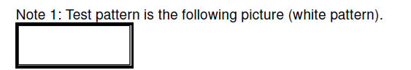

5.2 LED Driving Conditions
Item | Symbol | MIN | TYP | MAX | Unit | Remark
Forward Current | I_{F} | - | 360 | - | mA
Forward Voltage | V_{F} | 29.7 | - | 37.4 | V
Backlight Power consumption | W_{BL} | 10.7 | - | 13.46 | W
LED Lifetime |  | - | 50000 | - | Hrs

Note 1: Each LED: IF =90 mA, VF =2.7~3.4V.
Note 2: Optical performance should be evaluated at Ta=25℃ only.
Note 3: If LED is driven by high current, high ambient temperature & humidity condition. The life
Time of LED will be reduced. Operating life means brightness goes down to 50% initial brightness.
Typical operating life time is estimated data.

Interface Timing
6.1 8Bit LVDS input
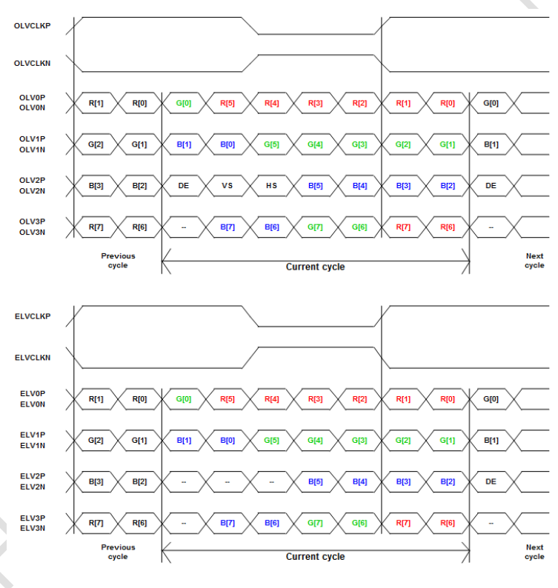

6.2 Interface Timing (DE mode)
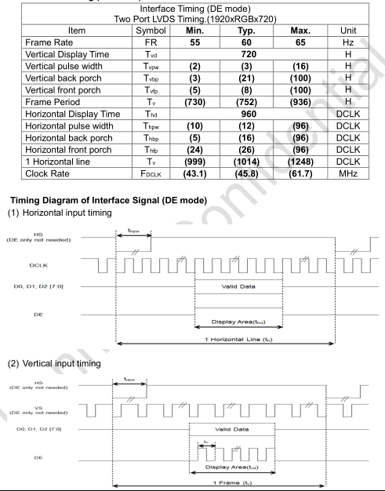

6.3 Power ON / OFF timing
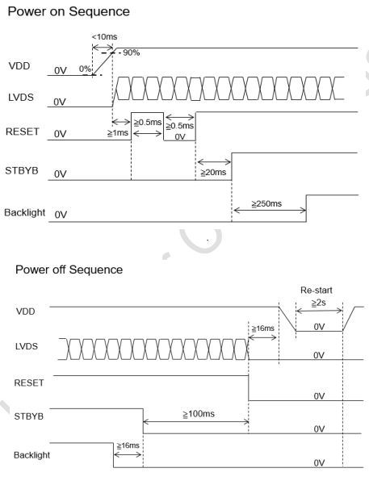

Optical Characteristics
Items |  | Symbol | Condition | Min. | Typ. | Max. | Unit | Remark | Note
Response time |  | Tr+Tf | - | - | 25 | 30 | ms | FIG.1 | Note4
Contrast Ratio |  | CR | - | 1100 | 1500 | - | - | FIG.2 | Note1
Surface  luminance |  | LV | θ=0° | 900 | 1000 | - | cd/m2 | FIG.2 | Note2
Luminance  uniformity |  | Yu | θ=0° | 70 | 75 | - | % | FIG.2 | Note3
NTSC |  | - | θ=0° | 65 | 80 | - | % | FIG.2 | Note5
Viewing angle |  | θ_{T} | Center  CR≥10 | - | 85 | - | deg | FIG.3 | Note6
 |  | θ_{B} | Center  CR≥10 | - | 85 | - | deg | FIG.3 | Note6
 |  | θ_{L} | Center  CR≥10 | - | 85 | - | deg | FIG.3 | Note6
 |  | θ_{R} | Center  CR≥10 | - | 85 | - | deg | FIG.3 | Note6
Chromaticity | Red | R_{X} | θ=0°  ∅=0°  Ta=25° | 0.604 | 0.654 | 0.704 | - | FIG.2  CIE1931 | Note5
Chromaticity | Red | R_{Y} | θ=0°  ∅=0°  Ta=25° | 0.269 | 0.319 | 0.369 | - | FIG.2  CIE1931 | Note5
Chromaticity | Green | G_{X} | θ=0°  ∅=0°  Ta=25° | 0.209 | 0.259 | 0.309 | - | FIG.2  CIE1931 | Note5
Chromaticity | Green | G_{Y} | θ=0°  ∅=0°  Ta=25° | 0.524 | 0.574 | 0.624 | - | FIG.2  CIE1931 | Note5
Chromaticity | Blue | B_{X} | θ=0°  ∅=0°  Ta=25° | 0.090 | 0.140 | 0.190 | - | FIG.2  CIE1931 | Note5
Chromaticity | Blue | B_{Y} | θ=0°  ∅=0°  Ta=25° | 0.034 | 0.084 | 0.134 | - | FIG.2  CIE1931 | Note5
Chromaticity | White | W_{X} | θ=0°  ∅=0°  Ta=25° | 0.253 | 0.303 | 0.353 | - | FIG.2  CIE1931 | Note5
Chromaticity | White | W_{Y} | θ=0°  ∅=0°  Ta=25° | 0.273 | 0.323 | 0.373 | - | FIG.2  CIE1931 | Note5

Note1. Definition of contrast ratio
Contrast ratio(Cr) is defined mathematically by the following formula. For more information see FIG.2.
Contrast ratio= | Luminance measured when LCD on the “White” state
Contrast ratio= | Luminance measured when LCD on the “Black” state
For contrast ratio, Surface Luminance, Luminance uniformity and CIE,the testing data is base on TOPCON’s BM-5 or BM-7 photo detector or compatible.
Note2. Definition of surface luminance.
Surface luminance is the luminance with all pixels displaying white. For more information see FIG.2.
Lv = Average Surface Luminance with all white pixels(P1,P2,P3, ......,Pn)
Note3. Definition of luminance uniformity
The luminance uniformity in surface luminance is determined by measuring luminance at each test position 1 through n, and then dividing the maximum luminance of n points luminance by minimum luminance of n points luminance.For more information see FIG.2.
YU= | Minimum surface luminance with all white pixels (P1,P2,P3,......,Pn)
YU= | Maximum surface luminance with all white pixels (P1,P2,P3,......,Pn)
Note4. Definition of response time
The response time is defined as the LCD optical switching time interval between “White” state and
“Black”state.Rise time (Tr) is the time between photo detector output intensity changed from 90% to 10%. And
fall time (Tf) is the time between photo detector output intensity changed from 10% to 90%.
For additional information see FIG1.
Note5. Definition of color chromaticity (CIE1931)
CIE (x,y) chromaticity,The x,y value is determined by screen active area center position P5.For more information see FIG.2.
Note6. Definition of viewing angle
Viewing angle is the angle at which the contrast ratio is greater than 10. Angles are determined for the horizontal or x axis and the vertical or y axis with respect to the z axis which is normal to the LCD surface. For more information see FIG.3.
For viewing angle and response time testing, the testing data is base on Autronic-Melchers’s ConoScope or DMS series Instruments or compatible.

FIG.1.The definition of response Time













FIG.2. Measuring method for contrast ratio, surface luminance,
luminance uniformity, CIE (x,y) chromaticity
Size : S≤5”(see Figure a) A: 5 mm B : 5 mm
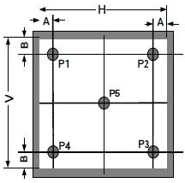
H,V : Active area
Light spot size ∅=5mm(BM-5) or ∅=7.7mm (BM-7)50cm distance or
compatible distance from the LCD surface to detector lens.
test spot position : see Figure a.
measurement instrument : TOPCON’s luminance meter BM-5 or
BM-7 or compatible (see Figure c).
Figure a

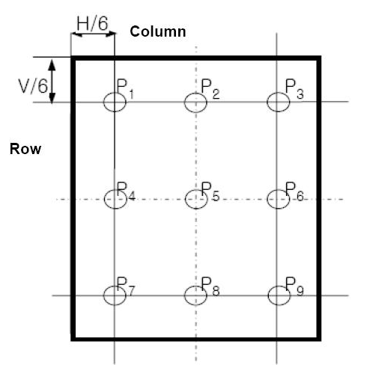
Size : 5”＜S≤12.3”(see Figure b) H,V : Active area
Light spot size ∅=5mm(BM-5) or ∅=7.7mm (BM-7)50cm distance or
compatible distance from the LCD surface to detector lens.
test spot position : see Figure b.
measurement instrument : TOPCON’s luminance meter BM-5 or
BM-7 or compatible (see Figure c).
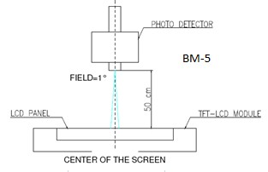

BM-5/BM-7

Figure b

Figure c
FIG.3.The definition of viewing angle


θ=0
Up
Φ=90
(12:00)

Left Right
Φ=180 Φ=0
(9:00) (3:00)
Down
Φ=270
(6:00)

Environmental / Reliability Tests
No | Test Item | Condition | Remarks
1 | High Temperature  Operation | Ts= +85℃, 96hrs | Note 1  IEC60068-2-2, GB2423. 2-89
2 | Low Temperature  Operation | Ta= -30℃, 96hrs | Note 2 IEC60068-2-1  GB2423.1-89
3 | High Temperature  Storage | Ta= +90℃, 96hrs | IEC60068-2-2  GB2423. 2-89
4 | Low Temperature  Storage | Ta= -40℃, 96hrs | IEC60068-2-1  GB/T2423.1-89
5 | High Temperature &  Humidity Storage | Ta= +60℃, 90% RH max,96 hours | IEC60068-2-3  GB/T2423.3-2006
6 | Thermal Shock  (Non-operation) | -40℃ 30 min ~ +95℃ 30 min  Change time: 5min, 30 Cycle | Start with cold temperature, end with high temperature  IEC60068-2-14, GB2423.22-87
7 | Electro Static Discharge  (Operation) | C=150pF, R=330 Ω, 5 points/panel  Air:±8KV, 5 times; Contact: ±4KV, 5 times; (Environment: 15℃ ~  35℃, 30% ~ 60%, 86Kpa ~ 106Kpa) | IEC61000-4-2  GB/T17626.2-1998
8 | Vibration (Non-operation) | Frequency range: 10~55Hz, Stroke:  1.mm Sweep: 10Hz~55Hz~10Hz  2 hours for each direction of X .Y. Z.  (package condition) | IEC60068-2-6  GB/T2423.5-1995
9 | Shock (Non-operation) | 60G 6ms, ± X, ±Y , ± Z  3 times for each direction | IEC60068-2-27  GB/T2423.5-1995
10 | Package Drop Test | Height: 80 cm, 1 corner, 3 edges,  6 surfaces | IEC60068-2-32  GB/T2423.8-1995

Note: 1. Ts is the temperature of panel’s surface.
2. Ta is the ambient temperature of sample.
3. The size of sample is 5pcs.

Mechanical Drawing

Packing
Packing Method
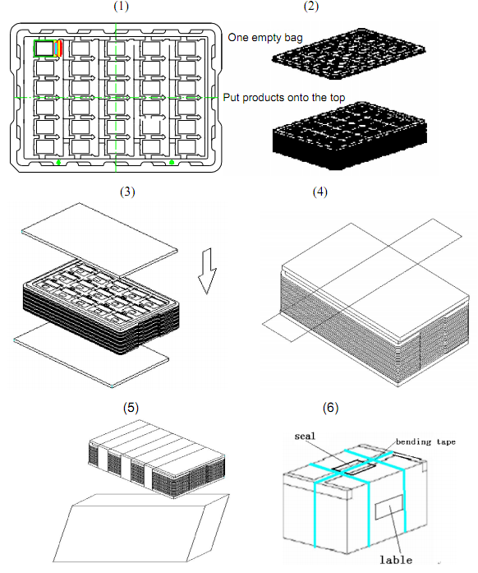
1. Put module into tray cavity:
2. Tray stacking
3. Put 1 cardboard under the tray stack and 1 cardboard above:
4. Fix the cardboard to the tray stack with adhesive tape:
5. Put the tray stack into carton.
6. Carton sealing with adhesive tape.

11.Precautions for Use of LCD modules
11.1 Handling Precautions
11.1.1. The display panel is made of glass. Do not subject it to a mechanical shock by dropping it from a high place, etc.
11.1.2. If the display panel is damaged and the liquid crystal substance inside it leaks out, be sure not to get any in your mouth, if the substance comes into contact with your skin or clothes, promptly wash it off using soap and water.
11.1.3. Do not apply excessive force to the display surface or the adjoining areas since this may cause the color tone to vary.
11.1.4. The polarizer covering the display surface of the LCD module is soft and easily scratched. Handle this polarizer carefully.
11.1.5. If the display surface is contaminated, breathe on the surface and gently wipe it with a soft dry cloth. If still not completely clear, moisten cloth with one of the following solvents:
－ Isopropyl alcohol
－ Ethyl alcohol
Solvents other than those mentioned above may damage the polarizer. Especially, do not use the following:
－ Water
－ Ketene
－ Aromatic solvents
11.1.6. Do not attempt to disassemble the LCD Module.
11.1.7. If the logic circuit power is off, do not apply the input signals.
11.1.8. To prevent destruction of the elements by static electricity, be careful to maintain an optimum work environment.
11.1.8.1. Be sure to ground the body when handling the LCD Modules.
11.1.8.2. Tools required for assembly, such as soldering irons, must be properly ground.
11.1.8.3. To reduce the amount of static electricity generated, do not conduct assembly and other work under dry conditions.
11.1.8.4. The LCD Module is coated with a film to protect the display surface. Be care when peeling off this protective film since static electricity may be generated.
11.2 Storage Precautions
11.2.1. When storing the LCD modules, avoid exposure to direct sunlight or to the light of fluorescent lamps.
11.2.2. The LCD modules should be stored under the storage temperature range If the LCD modules will be stored for a long time, the recommend condition is:
Temperature : 0℃ ～ 40℃ Relatively humidity: ≤80%
11.2.3. The LCD modules should be stored in the room without acid, alkali and harmful gas.

11.3 Transportation Precautions
The LCD modules should be no falling and violent shocking during transportation, and also
should avoid excessive press, water, damp and sunshine.

